## Installing weblogic on windows

1. Put JDK (not JRE) on path

2. Position in folder where you would like installation to take place

3. Run 'java -jar fmw*_12.2.x.x.x_*wls.jar.jar'

4. Change to folder wls12xxx

5. Run wlserver\server\bin\setWLSEnv.cmd

6. Run 'mkdir emrex'

7. Run 'cd emrex'

8. Run '%JAVA_HOME%\bin\java.exe weblogic.Server'

9. Specify user as 'weblogic'

10. Specify password as 'Welcome1'

11. Restart weblogic  
12. It is now possible to reach the server at <http://localhost:7001/console>

## Change listen port to 8000

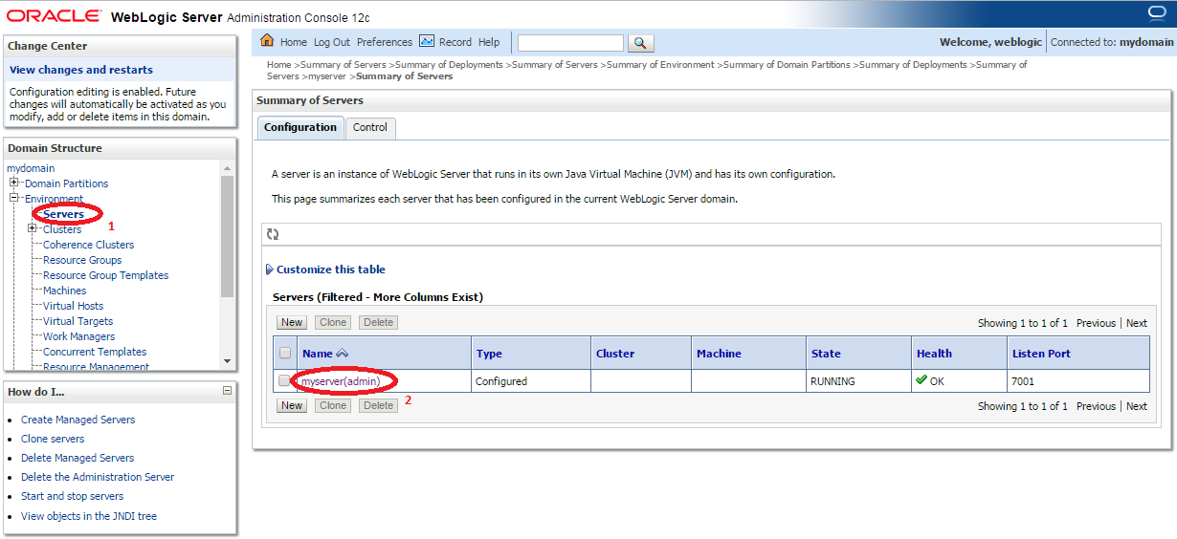

1. Click on servers
2. Click on your server

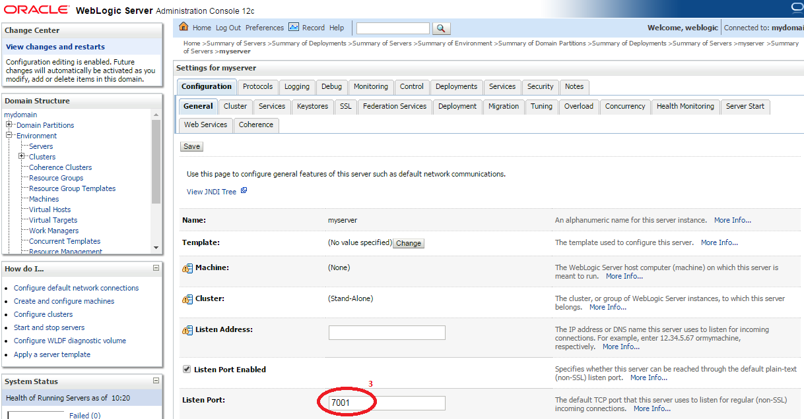

1. Set listen port to **8000**
2. Click the save button at the bottom of the page
3. Restart the server
4. It is now possible to reach the server at <http://localhost:8000/console>

## Deploying ncp application on the weblogic server

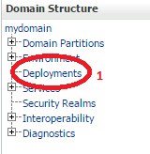

1. Go to “Deployments”

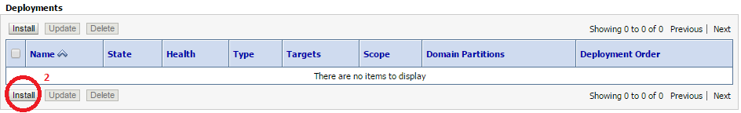

1. Choose “Install”

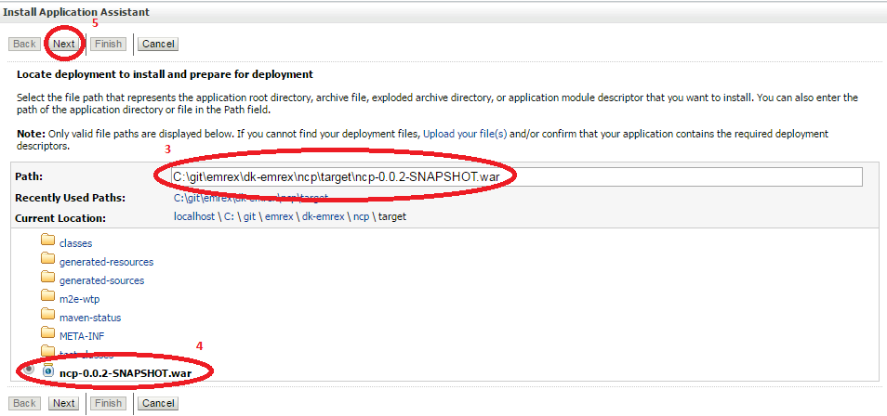

1. Navigate to the “target” directory of the “ncp” application.
2. Choose the .war file
3. Click “Next”

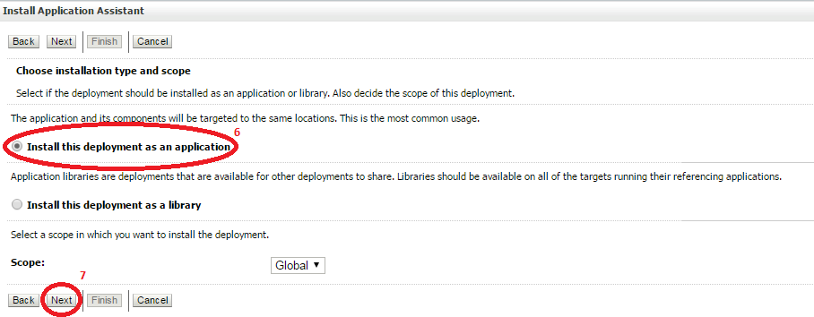

1. Choose “Install this deployment as an application
2. Click next

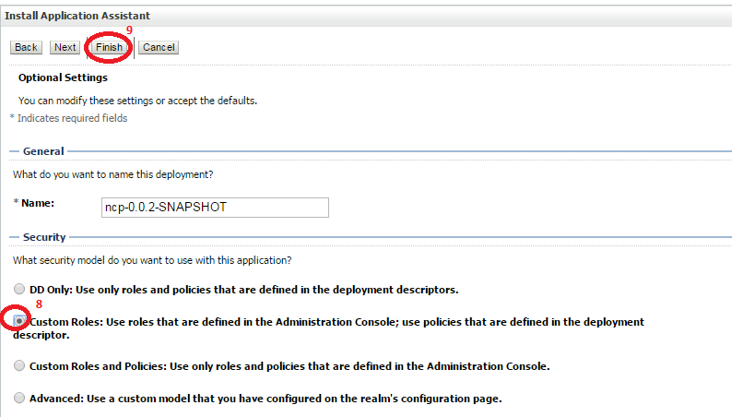

1. Choose “Custom Roles”
2. Click “Finish”

## Configuration of domain verification in oracle

The default configuration for weblogic discards * certificates, which is a problem since some of the web services in test are using *.stad.dk.

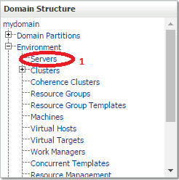

1. Go to “Servers” under Environment

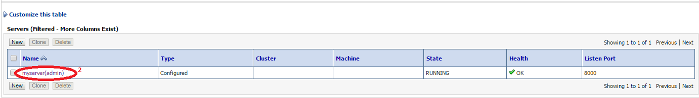

1. Choose your server

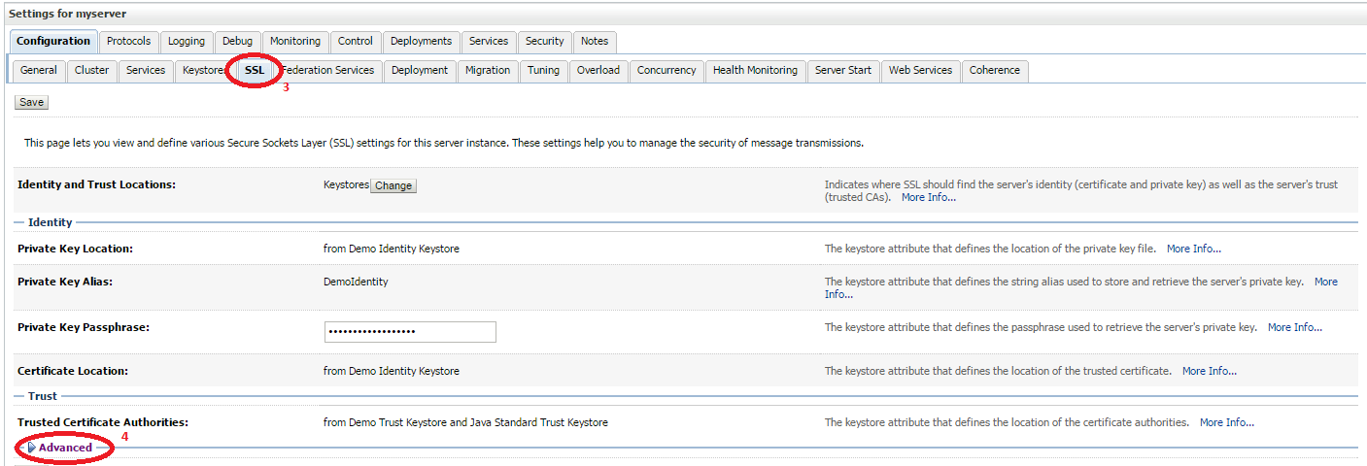

1. Choose the “SSL” Tab
2. Expand “Advanced”

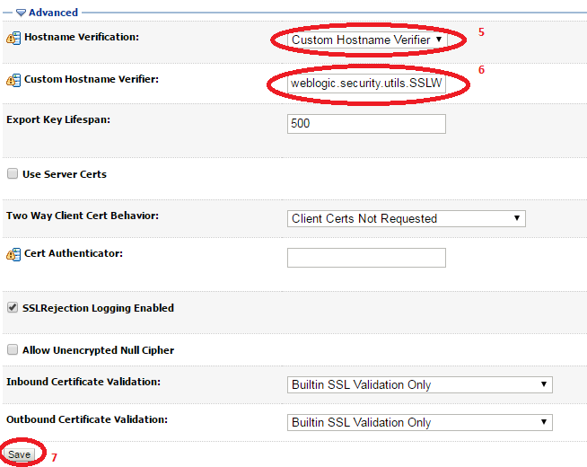

1. Choose “Custom Hostname Verifier”
2. Write **weblogic.security.utils.SSLWLSWildcardHostnameVerifier**
3. Click the save button
4. Restart the weblogic server

## Starting the weblogic server for environment specific setups

### Development environment

This is the default environment for the application, so start the webserver using the following command:

**%java_home%\bin\java.exe weblogic.Server**

### Test environment

Start the webserver using the following command:

**%java_home%\bin\java.exe -Dspring.profiles.active=test weblogic.Server**

### Production environment

Start the webserver using the following command:

**%java_home%\bin\java.exe -Dspring.profiles.active=prod weblogic.Server**